Green's theorem

Statement

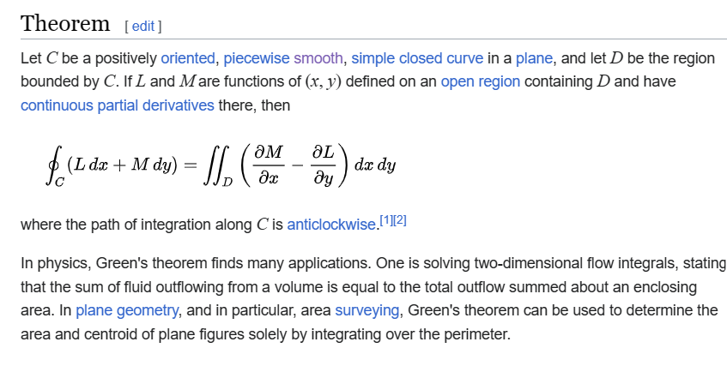

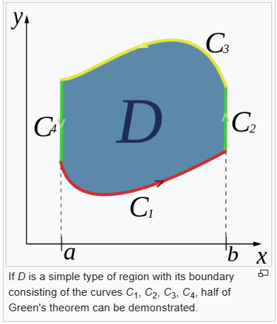

Proof

Ref

[Green's theorem - Wikipedia](https://en.wikipedia.org/wiki/Green%27s_theorem)